Redcap note

1. Through Designer/Data dictionary to create instruments and variables inside them

Online designer:

Click  to create new instrument and inside each instrument can

* Filed type: type of the data
* Filed label: detail about the data, in survey shown as the question asked
* Variable name: column name of the instrument
* Required?: is about whether this data can leave as blank

Note: for datetime, we can add validation

Or download the current data dictionary to fill in added information and upload the new data dictionary.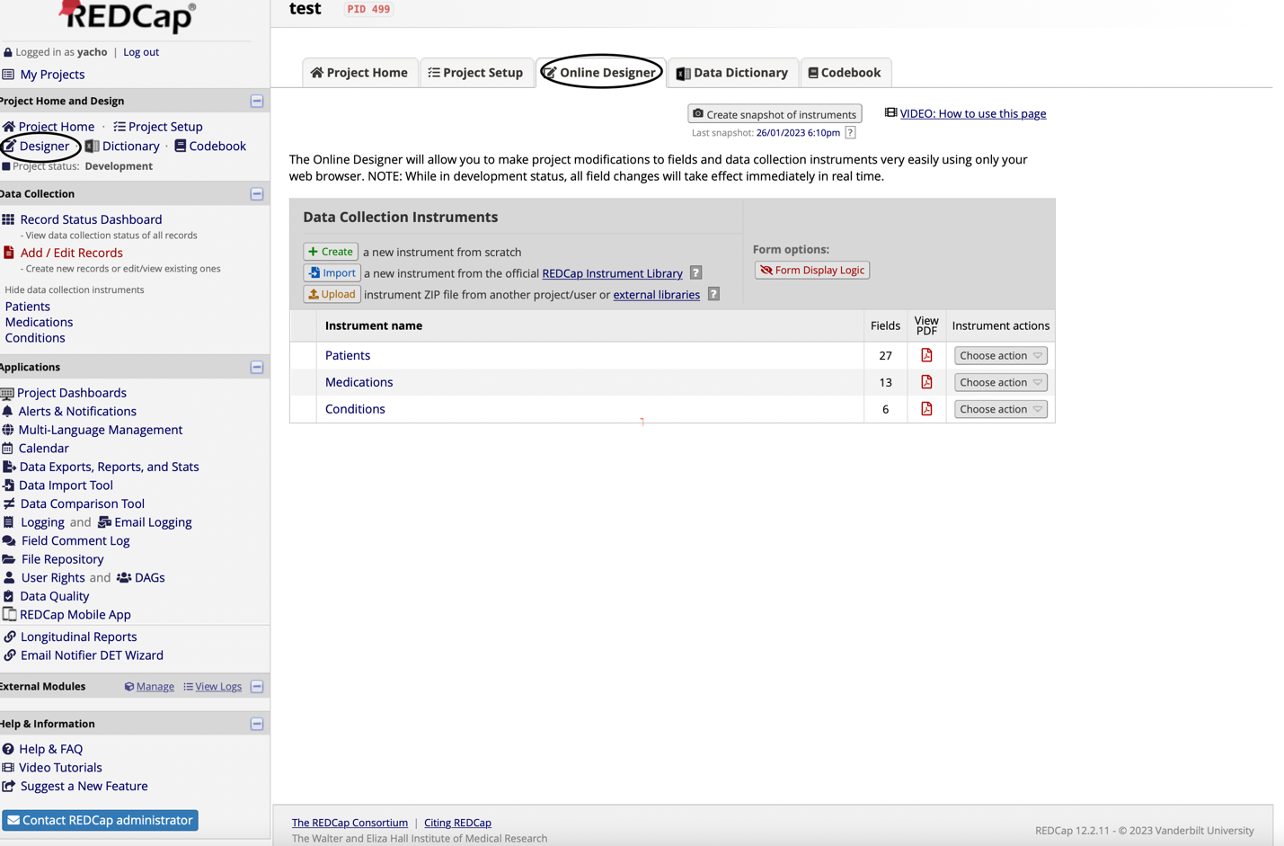

In codebook, it can have an overview on the generated instrument and fields

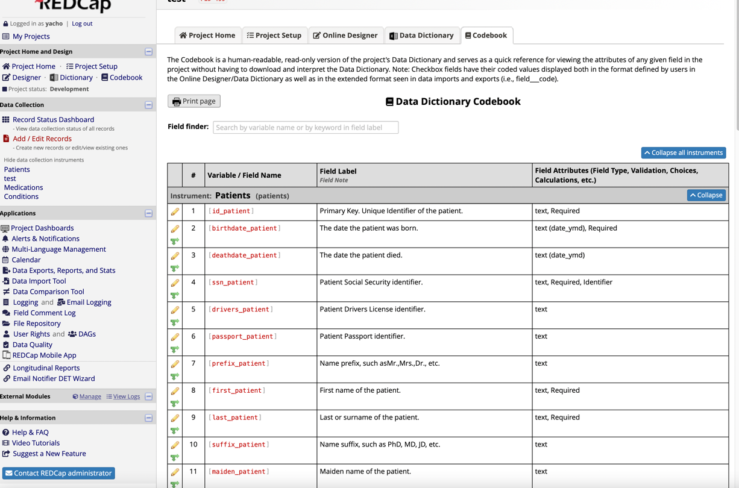

1. Import data (for csv file it could be through Data import Tool) generally, download the template file, fill the data into that template file and submit the filled file， if the csv file is too large, it is required to split into smaller CSV files to upload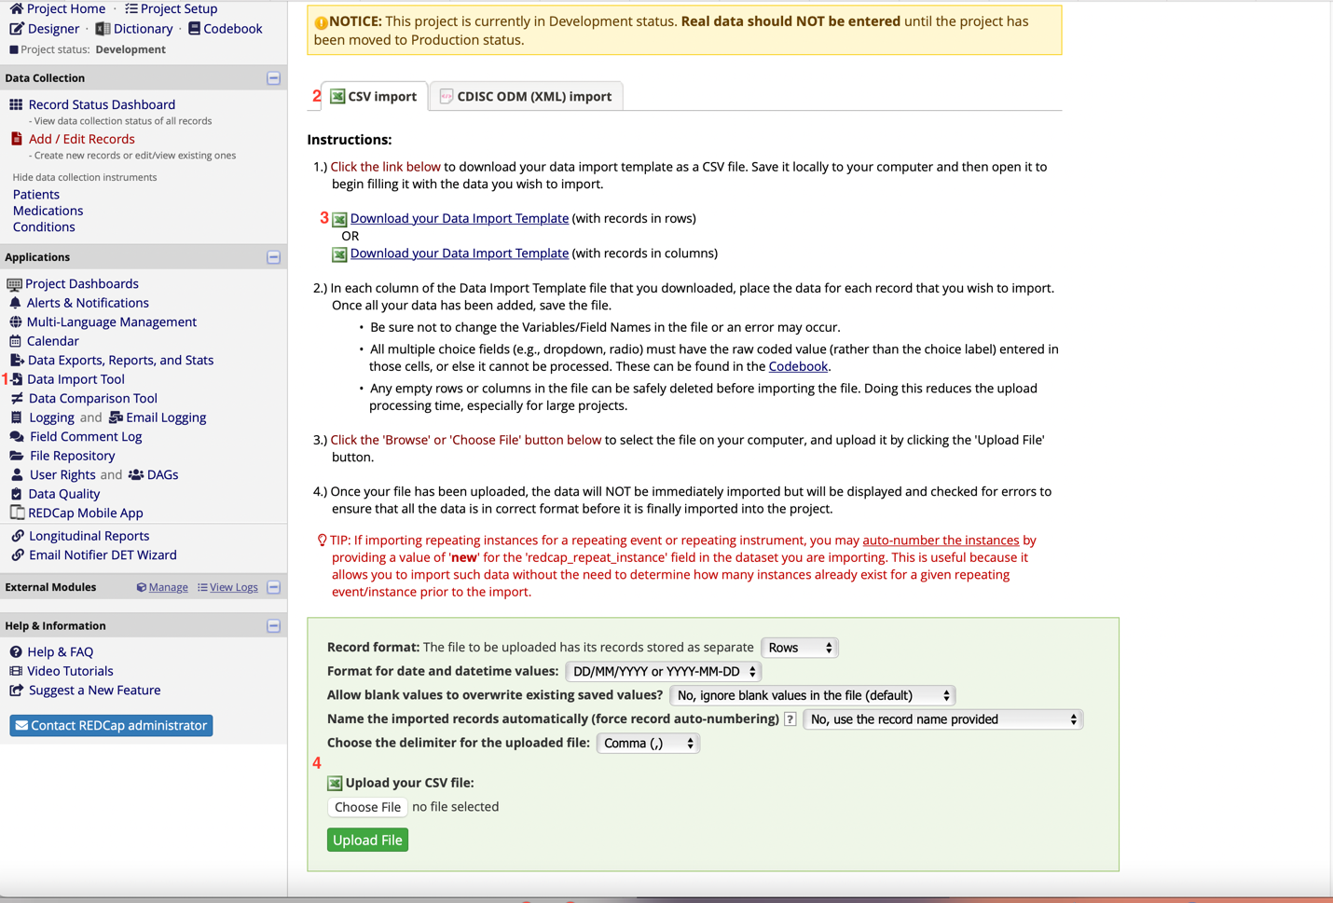

For our case, as a patient can have multiple conditions and medications, we need to change the project setup to allow repeatable instruments, so that each patient id could relate to multiple conditions and medications

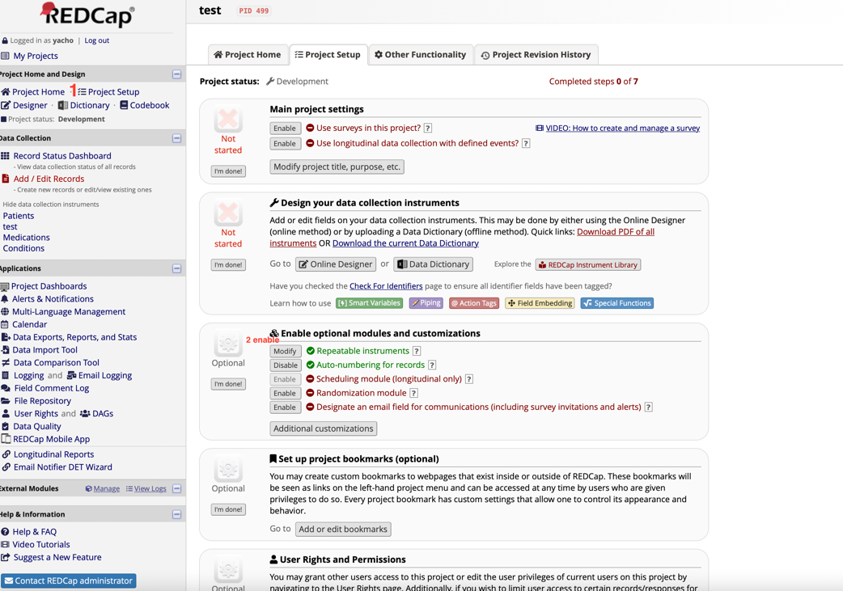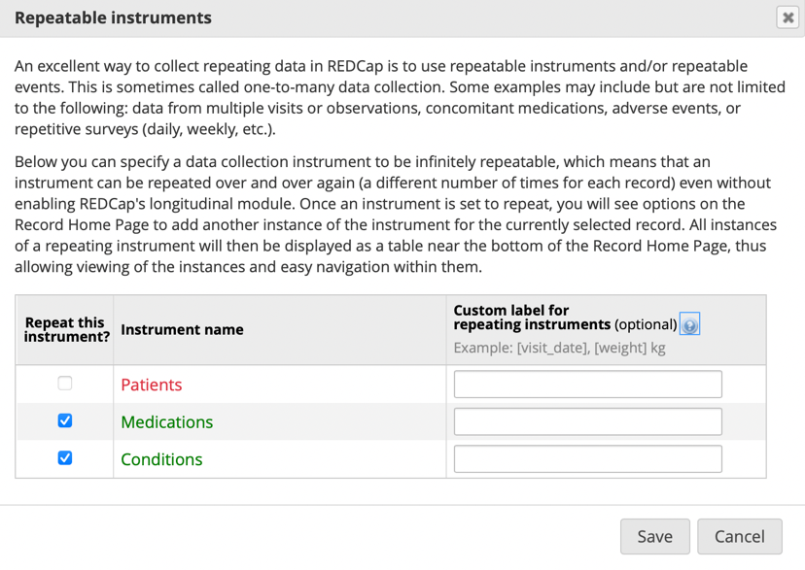

Note: when import dataset with repeating instance for the instrument, we found that there is two more columns(redcap_repeat_instrument, redcap_repeat_instance) in Data import Template.

The redcap_repeat_instance can set as ‘new’, while the redcap_repeat_instrument need to be all lowercase!